Machine learning in baseball game prediction and the application of trustable AI

David Huang¹, Ray I. Chang¹*
¹Department of Engineering Science, United Texas University, USA
Corresponding author: rayi@utu.edu

ABSTRACT

Each manuscript must include a concise, well-written abstract presented as a single continuous paragraph of no more than 300 words. The abstract must be formatted in 12-point Times New Roman with double line spacing. It should clearly and accurately summarize the purpose of the study, the methods or approach used, the principal findings, and the main conclusions or implications of the research. Because the abstract may be indexed, distributed, and read independently of the full article, it must be fully self-contained and understandable on its own. Authors should avoid the use of citations, footnotes, figures, and tables within the abstract. When absolutely necessary, references may be mentioned only by author name and year of publication without full bibliographic details. Non-standard abbreviations, symbols, and specialized terms should be avoided; if their use is unavoidable, they must be clearly defined at their first appearance in the abstract. The abstract must be written in a formal academic tone, avoid speculative or promotional language, and reflect only information that is fully supported in the main manuscript.

KEYWORDS: Provide 5 to 6 keywords that best represent the core topics of your manuscript. Use specific, singular terms in American English (e.g., 'modeling' not 'modelling'). Avoid general phrases and connectors (e.g., 'and', 'of'). Only use abbreviations that are universally recognized in the field (e.g., 'AI' is acceptable).

Introduction

The introduction should describe the research background, define the problem or knowledge gap being addressed, explain the importance of the study, and clearly state the research objectives or questions. It should provide sufficient context to position the work within existing literature. Citations in the related works section must follow APA author–date style (e.g., Smith, 2022), and all references must be formatted according to the latest APA guidelines.

Related Works

Sub-subsection header

Methods

Authors must clearly describe the study design, materials, procedures, and analytical methods used so that the research can be understood and replicated. Any specialized equipment, software, and statistical techniques must be identified and properly referenced.
Tables must be provided in editable text format and must not be submitted as images. Each table must be numbered consecutively according to its first appearance in the text and must include a concise and descriptive title as Table 1. Column headings must be brief and clearly defined. Units of measurement must be stated in the column headers, and all abbreviations must be explained in footnotes below the table. Explanatory notes, symbols, and data sources should appear directly beneath the table body. Authors should use tables selectively and ensure that information presented in tables does not duplicate data already described in the text.

Table 1 Performance Metrics of Machine Learning Models for Baseball Game Prediction
Model | Accuracy (%) | Precision (%) | Recall (%) | F1 Score (%)
Regression | 78.5 | 80.2 | 76.1 | 78.1
Random Forest | 84.3 | 85 | 83.2 | 84.1
Support Vector | 81.7 | 82.5 | 80.4 | 81.4
Neural Network | 86.9 | 87.3 | 86 | 86.6
Boosting | 88.1 | 88.7 | 87.5 | 88.1

System Design

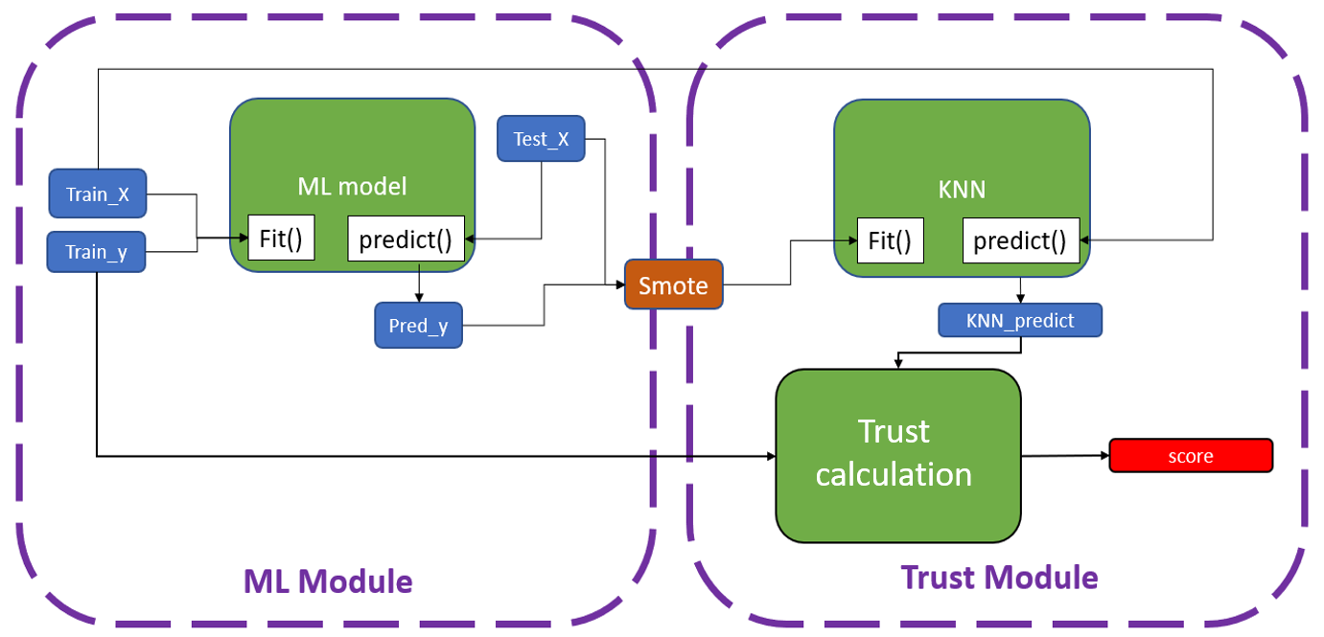
Figure 1 Structure of Machine Learning module and Trust module

Each figure or illustration must have a caption provided separately from the image file as Figure 1. Captions should include a concise title and a brief description of the content. Minimize text within the figure itself, and clearly explain all symbols, abbreviations, or notations used in the caption. Artwork files should be submitted in high-quality formats such as TIFF, JPEG, EPS, PDF, or Microsoft Office files, and must meet the resolution requirements for publication. If color figures are submitted and accepted, they will be published online in full color at no additional cost, regardless of whether they appear in color in the print version. Authors should consult the journal’s detailed guide on electronic artwork for specific formatting and resolution guidelines.

Analysis and Discussion
This section interprets the study’s results, integrating them with existing literature. Authors should highlight patterns, relationships, and implications, providing a critical assessment that contextualizes findings and supports meaningful conclusions.

Experiment Results
Present the results of all experiments clearly and systematically. Include key data, trends, and observations. Use tables, figures, and descriptive text to summarize findings objectively, without interpretation or speculation.

Findings and Contributions
Summarize the main outcomes of the study. Explain how these findings advance knowledge, provide theoretical insights, and offer practical or applied implications, highlighting originality and relevance within the research field.

Conclusion
The conclusion should deliver a powerful final synthesis. It must state the main answer to the research question and interpret its meaning, moving beyond a summary to explain why the results matter. Authors should clearly articulate the theoretical or practical implications of their work, acknowledge key study limitations, and propose specific, logical directions for future research. The final sentences should provide a compelling take-home message that underscores the paper's contribution to the field. Crucially, no new results or references should be introduced. This section transforms findings into lasting scholarly impact.

Funding Statement (Mandatory): All sources of financial support for the research must be explicitly declared. List grants and awarding bodies, including grant numbers where applicable. If no external funding was received, state: "This research received no external funding."
Format example: "Funding: This work was supported by the National Science Foundation [grant number 12345]."

Acknowledgments (Optional): Here, recognize individuals or organizations who provided assistance that does not merit authorship. This includes technical support, access to facilities, language editing, or substantive feedback. Format example: "The authors thank [Name/Group] for [specific contribution].

Reference List
The reference list should be arranged alphabetically by the authors’ last names. If multiple works by the same author(s) appear, order them chronologically. When an author has more than one publication in the same year, distinguish them using letters (e.g., 2010a, 2010b).

Journal Article
Davis, G. A., & Yihong, G. (1993). Statistical methods to support induced exposure analysis of traffic accident data. Transportation Research Record, 1404(1), 43–49.
Van der Geer, J., Hanraads, J. A. J., & Lupton, R. A. (2010). The art of writing a scientific article. Journal of Science Communication, 163, 51–59.

Book
Fleming, T. R., & Harrington, D. P. (1990). Counting process and survival analysis. John Wiley & Sons.
Strunk, W., Jr., & White, E. B. (2000). The elements of style (4th ed.). Longman.

Chapter in an Edited Book
Mettam, G. R., & Adams, L. B. (2009). How to prepare an electronic version of your article. In B. S. Jones & R. Z. Smith (Eds.), Introduction to the electronic age (pp. 281–304). E-Publishing Inc.
Conference Proceedings Paper
Patel, R., & O’Brien, S. (2022, June). Quantum encryption in 5G networks. Proceedings of the 2022 IEEE International Conference on Communications (pp. 1–6). IEEE. https://doi.org/10.1109/ICC.2022.9876543
Published Patent
Smith, J. A., & Garcia, R. L. (2020). U.S. Patent No. 10,987,654B2: Method for carbon capture using porous nanomaterials. U.S. Patent and Trademark Office.
Thesis or Dissertation
Kim, Y. (2023). Microplastic pollution in freshwater ecosystems: A regional analysis [Doctoral dissertation, Stanford University]. ProQuest Dissertations Publishing.
Technical Report
World Health Organization. (2021). *Global patient safety report 2021: Reducing medication-related harm* (Report No. WHO/HIS/SDS/2021.5). https://www.who.int/publications/i/item/9789240032475
Website or Online Document
Centers for Disease Control and Prevention. (2023, May 15). *Data on COVID-19 vaccination deliveries and administration*. https://covid.cdc.gov/covid-data-tracker/#vaccinations

